Riphah International University
(Sahiwal City Campus)


Department of Computing & Innovation
Semester Project Report
Course: Computer Organisation and Assembly Language
Course Code: CS2213
Project Team
STUDENT NAME | STUDENT ID | PROGRAMME | CONTACT
Moeez Ur Rahman | 3245 | Bachelor of Science in Artificial Intelligence | f24-bsai-0036@student.riphahsahiwal.edu.pk

To Course Instructor:
Muhammad Asif Tahir

Project Proposal

Project Title: Vault
Table of Contents

Index i

Executive Summary ii

1. Introduction 1

2. Existing System 1–2

3. Problem Statement 2

4. Proposed Solution 2

5. Scope of the Project 3

6. Implementation Tools and Techniques 4

7. System Architectural Design 5

8. Expected Outcome 6

9. Conclusion 6

REFERENCES 6

Executive Summary
Vault is a menu-driven Simple Banking System developed using 8086 Assembly Language and implemented on the EMU8086 emulator as part of the Computer Organisation and Assembly Language course. The project demonstrates the practical application of low-level programming concepts by simulating basic banking operations in a memory-based environment.
The system allows users to create up to three distinct accounts and perform essential banking functions such as balance enquiry, deposit, and withdrawal. Account information is stored and managed using memory arrays, while user interaction is handled through DOS interrupt services. The implementation uses arithmetic instructions, conditional branching, loops, and efficient register management.
This project is of intermediate complexity, suitable for Semester 3, and bridges the gap between simple assembly programs and real-world system simulations. It reinforces key concepts of computer organisation and assembly language programming while remaining fully compatible with the EMU8086 environment.

1. Introduction
Understanding how systems work at a low level is often overlooked when using high-level programming languages.
Vault is a menu-driven Simple Banking System developed using 8086 Assembly Language and implemented on the EMU8086 emulator. The project shows how basic banking operations, such as creating accounts, checking balances, depositing, and withdrawing money, can be implemented using memory arrays and simple arithmetic and logical operations. Users interact with the system through a menu-driven interface, and all operations are handled in memory during program execution.
This project provides practical experience with core concepts of Computer Organisation and Assembly Language. It helps students connect theoretical knowledge with real-world system behaviour by demonstrating how registers, memory management, loops, and conditional branching are used to implement functional programs.

2. Existing System

- Spread Sheet Based Banking Records:
Small organisations sometimes use spreadsheet software to manage account balances and transaction details. These systems reduce paperwork, but they depend heavily on manual input and do not provide strong control over data security or logical flow.
- Commercial Banking Software:
Commercial banking software offers features such as secure databases, user authentication, and real-time transaction processing. These systems are reliable and efficient, but they are complex, costly, and not suitable for low-level academic implementation or learning assembly language.
- Online Baking Systems:
Online banking systems allow users to manage accounts remotely through web or mobile platforms. They provide high convenience and security, but they rely on advanced technologies and architectures that are beyond the scope of a basic assembly language project.
- Vault (Simple Banking System):
Vault is a lightweight, memory-based banking system developed for educational purposes. It focuses on demonstrating core assembly language concepts such as arithmetic operations, loops, conditional branching, and array handling. Although it does not include real-world security or file handling, it is efficient, easy to use, and suitable for academic learning.
Table showing comparison of banking systems using different methods

Banking System | Accuracy | Security | Ease of use | Cost
Spread Sheet Based Banking Records | Low | Low | Difficult | Low
Commercial Banking Software | High | High | Medium | High
Online Banking Systems | Very High | Very High | Easy | High
Vault  (COAL Project) | Medium | Medium | Easy | Low

3. Problem Statement
Many small-scale banking record systems are either manual or based on high-level software, which makes it difficult to understand how financial data is processed at the hardware level. Manual methods are slow and prone to errors, while high-level systems hide the internal processing behind software abstractions.
Because of these limitations, students often do not get practical experience in implementing complete systems using assembly language. There is a need for a structured, intermediate-level project that allows students to simulate basic banking operations while applying core concepts of Computer Organisation and Assembly Language. This provides a controlled and educational environment for understanding low-level programming and system behaviour.

4. Implemented Solution
The Vault system was successfully developed using 8086 Assembly Language. It features a continuous loop menu that directs the user to one of five sub-routines:
- Create Account: Initialises an index in the accFlag array.
- Deposit: User input added to the value stored in the accounts array.
- Withdraw: Subtracts user input from the accounts array after a safety check (jb - jump if below).
- Check Balance: Retrieves the hex value from memory and converts it to ASCII decimal for display.
- Exit: Terminates the program and returns control to the OS.

5. Scope of the Project
Account Management Module:
- Capacity: The system supports exactly 3 unique accounts (IDs 1, 2, and 3) using a 0-indexed array approach.
- Status Tracking: Uses a flag array (accFlag) to ensure accounts are created before being used.
Transaction Limits:
- Input Size: The system accepts 2-digit inputs (00-99) for all transactions to ensure stability within the 8-bit register limits.
- Validation: Withdrawal logic includes a comparison (cmp) to prevent overdrawing funds (Negative Balance Protection).
Arithmetic & Display:
- Processing: All calculations are performed in the Accumulator (AX) and Base (BX) registers.
- Output: Includes a custom ‘Push/Pop’ stack loop to convert internal binary numbers into human-readable decimal digits for the ‘Check Balance’ feature.
User Interaction Module:
- Provide a menu-driven interface using DOS interrupts.
- Accept user input for selecting operations and account IDs.
Educational Scope:
- Demonstrates the practical application of Computer Organisation and Assembly Language concepts.
- Provides an intermediate-level project for Semester 3 students.

6. Implementation Tools and Techniques
The tools and programming language used to develop Vault are as follows:
Front End
- The system uses a console-based, menu-driven interface to interact with users.
Development Environment
- Emulator: EMU8086
- Programming Language: 8086 Assembly Language
- The back end is fully implemented in assembly instructions, using registers and memory for calculations and data storage.
Data Storage
- All account information is stored in memory arrays within the program.
- Although EMU8086 supports basic file handling through DOS interrupts, file operations are not used in this project. This choice keeps the implementation simple, avoids extra complexity such as buffer management and data formatting, and allows the focus to remain on demonstrating core assembly language concepts.
- Memory-based storage is sufficient to simulate multiple accounts and perform banking operations during program execution. All data exists temporarily while the program is running.
Key Assembly Concepts Used
- Procedures (PROC): Modular code was used for GetAccountID and GetAmountTwoDigits to reduce redundancy.
- The Stack: utilized heavily in the CheckBalance module to reverse the order of digits during the Binary-to-ASCII conversion process.
- Interrupts: INT 21h (Functions 09h, 01h, 02h) handled all screen I/O.
This implementation provides a complete assembly language solution that demonstrates fundamental concepts of Computer Organisation and Assembly Language. It is designed as an intermediate-level project suitable for Semester 3 students, giving practical experience in low-level programming, memory management, and system behaviour.

7. System Architectural Design
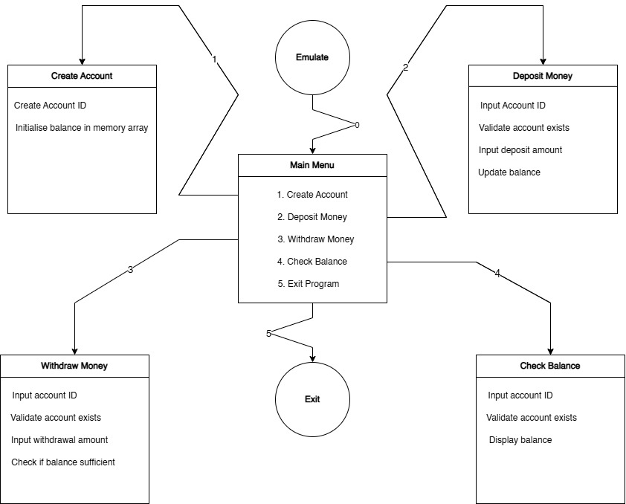

Data Flow Logic:
- Start: Initialise Data Segment (DS).
- Menu Loop: Display options 1-5.
- Input: Read char.
- If '1': Jump to CreateAccount → Check accFlag → Update accFlag & accounts → Return.
- If '2': Jump to Deposit → Get ID → Get Amount → ADD to memory → Return.
- If '3': Jump to Withdraw → Get ID → Get Amount → Compare Balance → SUB from memory → Return.
- If '4': Jump to CheckBalance → Get ID → Read Memory → Divide by 10 Loop → Print Digits → Return.
- If '5': MOV AH, 4Ch → INT 21h (Exit).

8. Project Outcome:
For Vault (Simple Banking System), the final code successfully achieved the following:
- A fully functional, menu-driven banking simulation running on EMU8086.
- The application runs without crashing on invalid inputs (e.g., entering an ID of '5' or '0' triggers the errorID handler).
- The math operations correctly handle sums and differences within the 8-bit limit.
- The system provides immediate text feedback (e.g., ‘Insufficient Balance!’ or ‘Deposit successful!’).
- The system provides clear DOS-based console output, showing menus, prompts, and transaction confirmations.
- Demonstrates practical application of assembly language concepts such as loops, conditional jumps, registers, and memory arrays.
- Provides educational value by showing how low-level programming can simulate basic banking operations in a controlled environment.

9. Conclusion:
Vault demonstrates how a simple banking system can be implemented using 8086 Assembly Language on the EMU8086 emulator. The project allows students to create accounts, perform deposits and withdrawals, and check balances, all while using memory arrays, registers, loops, and conditional branching.
Hands-on experience in low-level programming and how core concepts of Computer Organisation and Assembly Language be applied to simulate practical systems can be learned by building Project Vault. The project provides an intermediate-level challenge for Semester 3, bridging the gap between theoretical knowledge and practical implementation, and reinforcing understanding of memory management, arithmetic operations, and program flow control in assembly language.

REFERENCES
1. EMU8086 Documentation
- User guide and examples for EMU8086 emulator.
- https://emu8086-microprocessor-emulator.en.download.it/
- http://www.coval.net/teach/emu8086/index.htm
- https://archive.org/details/tucows_325007_Emu8086_-_Microprocessor_Emulator
2. Riphah International University, Sahiwal City Campus:
- Computer Organisation and Assembly Language course material for semester 3 of 8 students of B.Sc. in A.I.



